**DAILY ONLINE ACTIVITIES SUMMARY**

|  |  |  |  |  |  |  |  |  |
| --- | --- | --- | --- | --- | --- | --- | --- | --- |
| **Date:** | 22/05/2020 | | | | | **Name:** | BHAVYA. S | |
| **Sem & Sec** | 4th SEM ‘A’ Section | | | | | **USN:** | 4AL18CS014 | |
| **Online Test Summary** | | | | | | | | |
| **Subject** | | Operating systems(18CS43) | | | | | | |
| **Max. Marks** | | 30 | | **Score** | | | 19 | |
| **Certification Course Summary** | | | | | | | | |
| **Course** | Introduction to Programming | | | | | | | |
| **Certificate Provider** | | | Great Learning | | **Duration** | | | 1.5 Hours |
| **Coding Challenges** | | | | | | | | |
| **Problem Statement:** 1. Stack operation using SLL  2. Round robin type of process scheduling | | | | | | | | |
| **Status:** Completed | | | | | | | | |
| **Uploaded the report in GitHub** | | | | | YES | | | |
| **If yes Repository name** | | | | | <https://github.com/Bhavyamahadev/lockdown-coding> | | | |
| **Uploaded the report in slack** | | | | | YES | | | |

**Online Test Details:**

The online test was from module 1 which was about the introduction to operating systems, system structures, different operating system services and process management. There were 30 questions and the duration was 40 minutes. The questions were optimal and were easy. The score that I got in the test is 19/30.

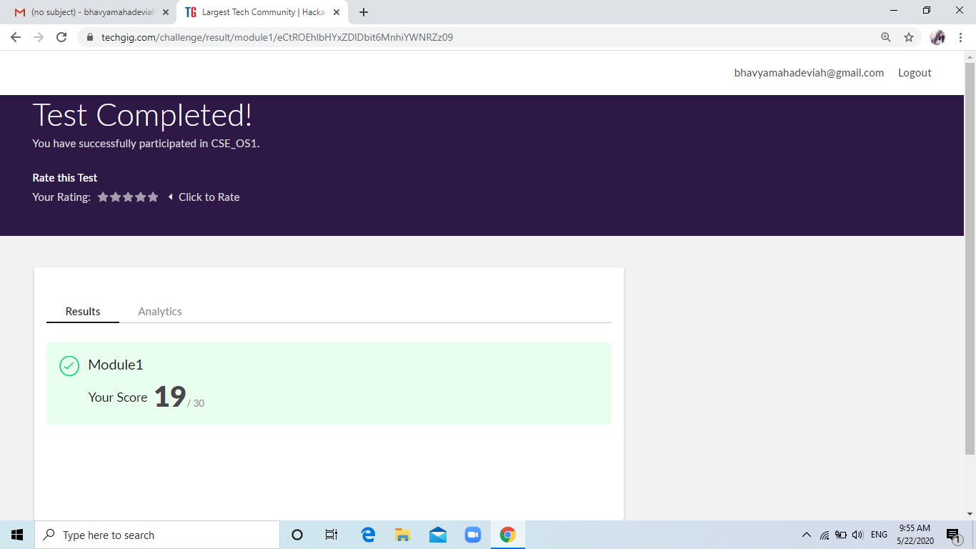

**Certification Course Details:**

**Name of the course**: Introduction to Programming

**Certificate Provider**: Great Learning

This course has 3 sections and the total duration is 5.5 hours.

In the fifth day I went through the second section of the course and learnt the Python OOPS and NumPy. I have gone through the Creating the class, Adding Parameters to Class Method, Inheritance in Python, Introduction to NumPy, Joining NumPy Arrays, NumPy Intersections and Difference.

**Snapshot:**

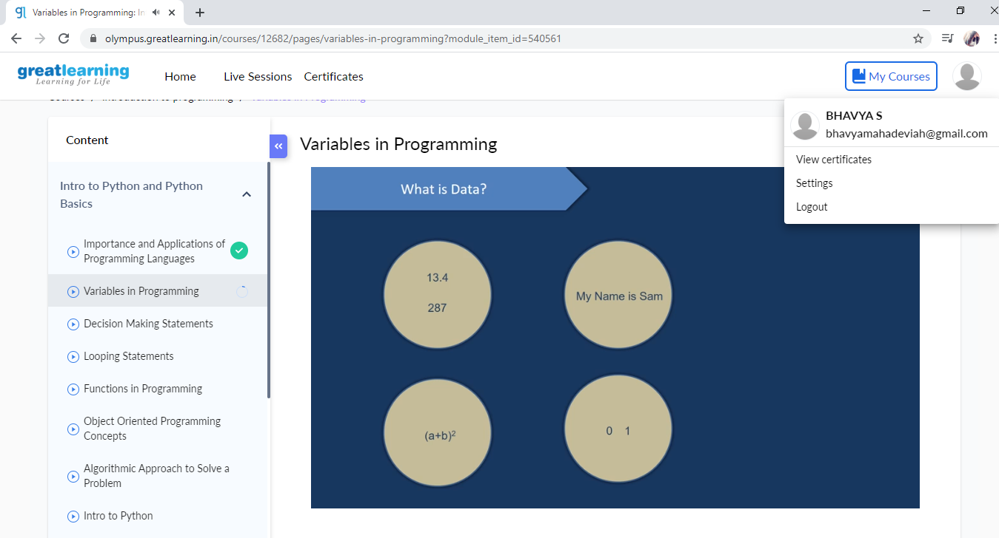

**Online Coding Details:**

Problem 1: (using C language) Do the basic operations on a stack where stack is implemented using singly linked list

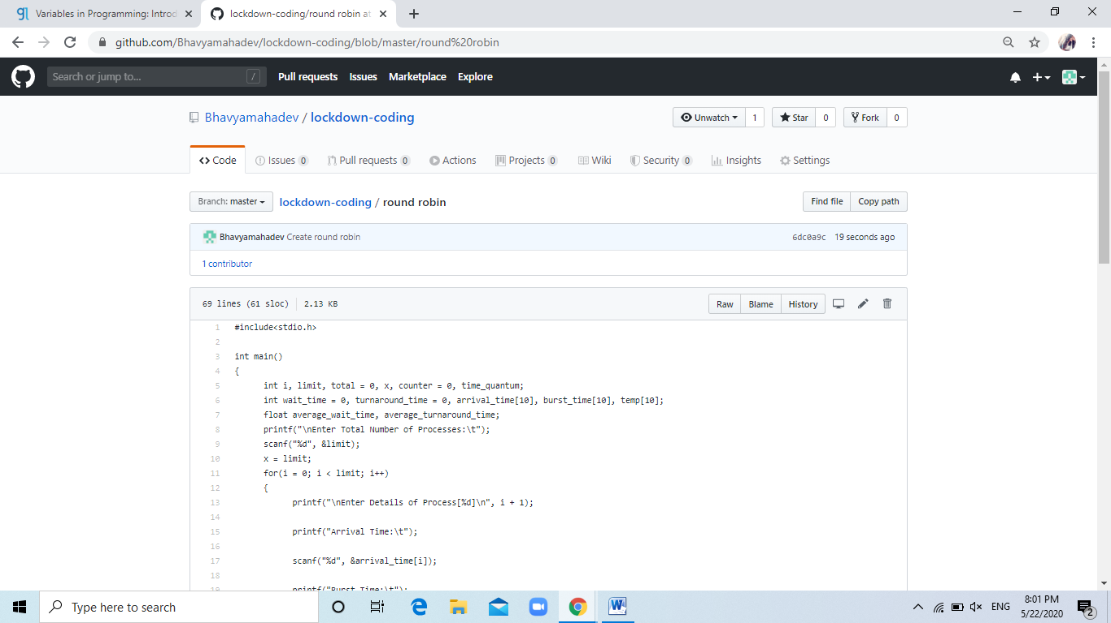

Problem 2: (Using C) Perform round robin type of process scheduling

